SAMPLE BLOG/NEWSLETTER POST


As the clock struck midnight on New Year’s Eve, the Valley sky exploded in color. Bursts of red, gold, and green painted the night, a dazzling welcome to 2025.
But as the cheers faded, something else lingered in the air.
When the sun rose over the Valley on New Year’s Day, an air quality monitor in West Phoenix recorded one of the worst pollution readings on the planet. The culprit wasn’t rush-hour traffic or wildfire smoke. It was our use of consumer fireworks.
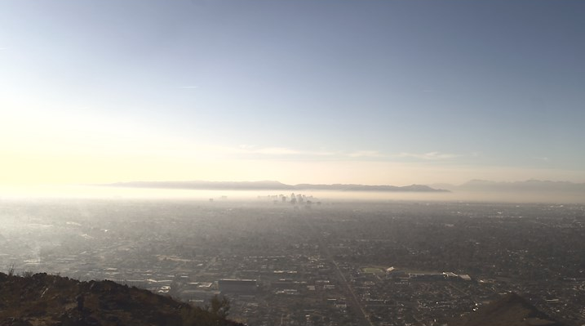
Credit: Arizona Department of Environmental Quality South Mountain Visibility Camera,9:30 am, January 1, 2025

A Beautiful Tradition with an Ugly Aftermath
Those glittering pyrotechnics may be a holiday staple, but they come at a price. Fireworks release clouds of fine particulate matter, known as PM-2.5, particles so small they can slip deep into the lungs and even enter the bloodstream.
On January 1, PM-2.5 levels in west Phoenix measured 258.1 micrograms per cubic meter. For context, the Environmental Protection Agency’s (EPA) daily standard is 35. That’s more than seven times higher, and high enough to push the Air Quality Index (AQI) to 366, a “Hazardous” level where even healthy people may feel the effects, according to the EPA.
A Valley-Wide Problem
West Phoenix wasn’t alone in its haze. Of the 15 worst PM-2.5 readings worldwide that day, four were right here in the Valley, including monitors in South Phoenix, the Durango Complex, and Mesa.
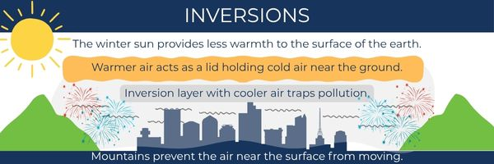
Due to the region’s climate and geography, the cooler months are prone to temperature inversions, a meteorological phenomenon in which warmer air pushes down on colder air near the ground, acting like a lid and preventing it from rising higher into the atmosphere. This traps pollutants near the ground, resulting in poor air quality. Consumer fireworks that explode below this invisible lid prevent the emissions released from firework explosions from dissipating. The result is a layer of air pollution that settles over neighborhoods like a heavy blanket. Learn more about inversions.
In addition to very high levels of PM-2.5, air analysis on January 1, 2025, shows elevated levels of harmful chemicals such as chlorine and chromium, which can be toxic.
What’s Next for the Valley’s Air
According to data from Maricopa County, consumer fireworks are the biggest reason for these New Year’s pollution spikes. And while the spectacle lasts only minutes, the environmental fallout lingers much longer, jeopardizing the region’s ability to meet federal air quality standards.
It’s a distinction no one wants, and a reminder that our celebrations can have consequences we can’t see.
The Maricopa Association of Governments (MAG) is working with local cities, towns, and counties to tackle air quality challenges like this one. Together, they’re helping the Valley find ways to celebrate without sacrificing the air we breathe.
Public awareness is critical to improving this situation. Information and shareable resources are available at azmag.gov/fireworks.

