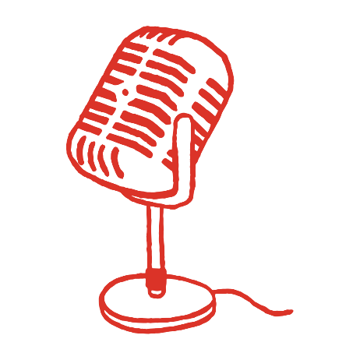
SAMPLE RADIO SCRIPT

Radio Script One – Backyard Party
<SFX: Sound of neighborhood celebration/backyard fireworks>
<ANNOUNCER>
Yes, fireworks are breathtaking.
<SFX: Partygoers sounding impressed with fireworks with “ohhs” and “ahhs”>
<ANNOUNCER>
But that’s not always a good thing.
When you use personal fireworks to celebrate, the air explodes with pollutants—like particulates and gases that can damage the lungs.
Last year, fireworks use led to the Maricopa Region having the third-worst air quality in the world…
The third worst in the world!
This year, let’s light the fuse of change. Reduce or eliminate your use of personal fireworks in holiday celebrations, so we can all celebrate cleaner air.
Learn more at azmag.gov/fireworks.

Radio Script Two – New Year’s
<SFX: Sizzle of lit firecracker>
<ANNOUNCER>
When a firecracker goes off…
<SFX: Single firecracker goes>
<ANNOUNCER>
…the air explodes with pollution—like particulates and gases that damage the lungs.
<SFX: Intensity/frequency of explosions grows>
<ANNOUNCER>
Multiply that by the tens of thousands of people doing it to celebrate New Year’s, and our air quality explodes into the danger zone.
Last year on New Year’s Day, the Maricopa Region had the third-worst air quality in the world.
The third worst in the world!
This year, help light the fuse of change.
<SFX: Frequency of fireworks going off begins to diminish>
<ANNOUNCER>
Reduce or eliminate your use of personal fireworks in holiday celebrations, and keep it joyous, not dangerous.
Learn more at azmag.gov/fireworks.

